Name ____Carl Snell_______________________________

Take Home Final Examination SPED 5111

Due through email by July 1, 2012 To: jkessler@temple.edu

Using Universal Design for Learning Principles, best practices regarding Differentiated Instruction, and information gained from our presentations on assistive/adaptive technology, please describe how you would teach reading and writing to students as they are described below. You will choose two case studies only. Decide on a specific reading/writing lesson with an anticipated specific learning outcome just as you did when you wrote your mini-lesson plans for this course. Please describe connections between your decisions and readings, course lectures, assistive technology presentation, our ACIT lab demonstration, and prezi presentations in order to inform your instructional decision-making.

**Case Study Three: Caryn**  
My name is Caryn. I am very interested in visual arts and eventually plan to attend a high school that focuses in the fine arts.

**Access Issues**  
Although I'm an art major, I have to take two English classes and a second language that are required by my high school. I have a language-learning disability which makes it difficult for me to understand and organize large amounts of verbal information. Writing was my most challenging academic area throughout my schooling. I was worried that I would not be able to keep up with the workloads and failing a class was not an option for me.

Think about ways in which Caryn can be accommodated appropriately. Please use an RTI framework in order to describe interventions (Tier 1, 2, 3 interventions and progress monitoring at each step)

  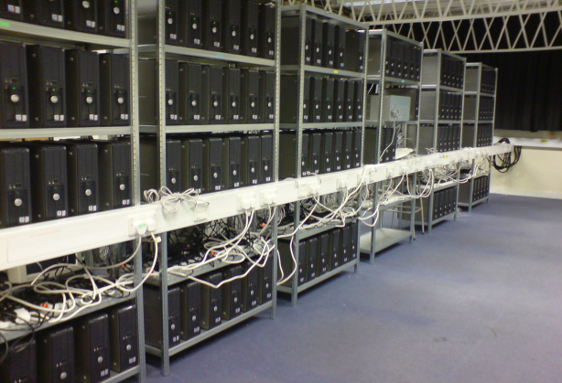  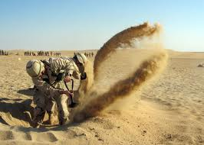 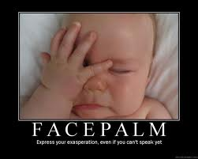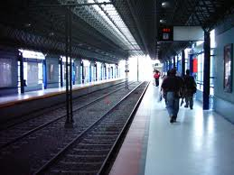 

Picture 1: furious, Picture 2: illumination, Picture 3: cluster, Picture 4: scavenged, Picture 5: accumulating

Picture 6: diligently, Picture 7: agitated, Picture 8: train station, Picture 9: muttered

Literacy MiniLessons

1. **Photogallery**

As a science teacher, I am aware that vocabulary can be a major hurdle to successful instruction. The use of visual reinforcement supports comprehension and retention. This should serve as a great entry point to engage an artistic student such as Caryn. Interacting with a large set of vocabulary words in multiple ways will help enable to approach words and their meanings more fully. The photogallery integrates technology into instruction while engaging students. It’s a great way to explore key terms recently added to a word wall. Students are asked to identify the term represented by each picture within the gallery and write a descriptive sentence for that term. Students can focus on enhancing their working vocabulary without losing time to searching for definitions. The photogallery also helps students visualize unfamiliar or historical settings for literature selections. It definitely is an engaging way to open a lesson to initiate discussion or garner attention for a lesson’s main activities.

1. **Storyboard (see attachment)**

A storyboard is a series of pictures that tell about an important event in a story. A storyboard can tell the story of only one scene – or the entire novel. Students complete the storyboard below illustrating the events described in the first two chapters of ***The Invention of Hugo Cabret***. You may wish to practice your drawings on a separate piece of paper. Writing has been Caryn’s most difficult subject, but this activity allows her to explore and express her ideas about story elements such as plot, setting, and character descriptions from an artist’s perspective. Caryn can sketch a scene and write her initial reactions and reflections that followed for each scene that she selects as one that helped her derive meaning from the story. While this functions as a reading log with visuals, Caryn may also choose to redraw or adapt an illustration from the book and describe its significance.

**Supplemental Activities Example**

**The Eiffel Tower**

One of the world’s most famous landmarks is the Eiffel Tower in Paris. The Eiffel Tower was built in 1889 and remains the tallest building in Paris – the second tallest in France. Using resources in your school library or on the Internet, investigate additional facts about this famous landmark. Below record three fascinating facts from your research.



1. **Mind Mapping Minilesson**

# What is mind mapping?

# Mind maps are, by definition, a graphical method of taking notes. Their visual basis should help Caryn to distinguish words or ideas, often with colors and symbols – universal design for learning. Since they generally take a hierarchical or tree branch format, with ideas branching into their subsections, this will also aid her attempts to handle larger volumes of verbal information. Mind maps allow for greater creativity when recording ideas and information, as well as allowing Caryn to associate words with pictures or symbols.

# Examples

# 

# How to mind map your way to success http://www.better-notes.com/how-to-mind-map.html

There are many other uses for this technique besides note taking. You can use it to solve problems, or generate new ideas, organize yourself, prepare a speech or presentation, for project management and much more.

1. The general principle is that you start in the centre of a piece of paper with the main subject of your map. Then draw curved lines from the centre for each important point or category that you want to add to the map. A good number of these main branches would be 5 to 7.
2. On main branches write a keyword to represent that line of thinking. Match the word length with the branch length. 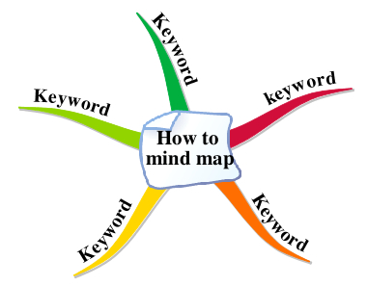
3. Then extend your ideas out further by creating sub-branches and sub-sub-branches.

When your imagination dries up and you can't think of any more sub branches to add to a main branch, don't struggle, but move on to a different branch.

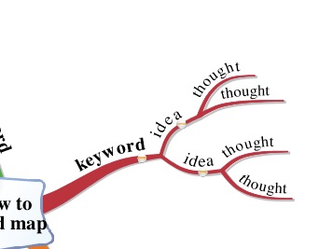

1. Place each idea where it fits best in the map, or if necessary include it more than once. If words on different branches have a relationship to each other you can draw a connecting line between them.

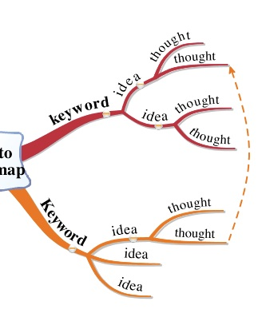

1. Add relevant images or symbols to your branches to bring your mind map to life. These will also help you to memorize the map.

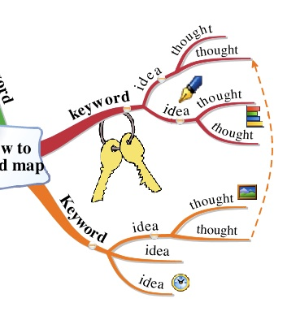

## Rules of mind mapping

### Use a central image

* 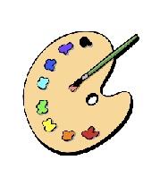A central image tells the viewer what information or subject the map is covering and is worth a thousand words! It encourages creative thoughts, allowing your mind to relax and form new associations. Making this central image colorful, and detailed, will also help you to recall the map later.

### Use a single word on each branch

### Use colors throughout

* Our minds are very good at remembering colors, so put them to good use in your maps.
* Use a different color for each main branch of your map. If you can, pick a color that reminds you of the main branch subject, for example green for outdoors or red for danger areas.
* If you can (or your software allows) try to use the same colored text as the branch it sits on. Compare the mind map below to the same one higher up the page. Do you think it would be easier to remember?
* At a quick glance it is easy to "read" the color rather than the actual words.

### Print the words

* This rule is only relevant if you are learning how to mind map on paper. Printed lettering rather than "joined up" is easier to read on a branch. For the same reason, do not use all capital letters.
* As your branches get further from the centre they should become thinner and the writing on them should generally be smaller. To make a particular word stand out you could break this rule, perhaps by writing a word such as "bigger" in letters of increasing size.
* Write the words so that you can read them without having to turn the paper around, unless you are aiming for a special effect on a single branch. Occasionally you might like to substitute a letter in a word with a simple sketch or symbol. An example that comes to mind would be the hands of a clock for the letter I in time.

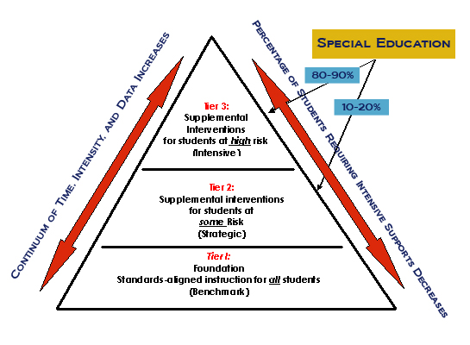

**Response to Intervention**

**Tier 1**: All lessons are to be geared to the Common Core State Standards and framed to include entry points for multiple learning styles as well as individual student interests. I will float around the classroom to observe, facilitate, and assess learning.

Tier 2: Class routines will include informal reading assessments such as the Gates MacGinite Reading Test, the Writing and Reading Assessment Profile, specific sections of the Stieglitz Informal Reading Inventory or the computerized Scholastic Reading Inventory as required on a case by case basis. Results will guide future lesson planning of minilessons, workshops, focus units, and scaffolding.

Tier 3: Specific and intensive plans will be crafted – with assistance from the special ed teacher and school counselor - for those students needed extra help beyond those that can be scaffolded into workshops, focus units, minilessons, and literature circles. Additional help may be requested from the Pennsylvania Institute for Adaptive Technology at Temple University or the Elwyn Institute.

**Figure 1:Organizing the School for Tiered Instruction**

<http://www.rtinetwork.org/essential/tieredinstruction/tiered-instruction-and-intervention-rti-model>